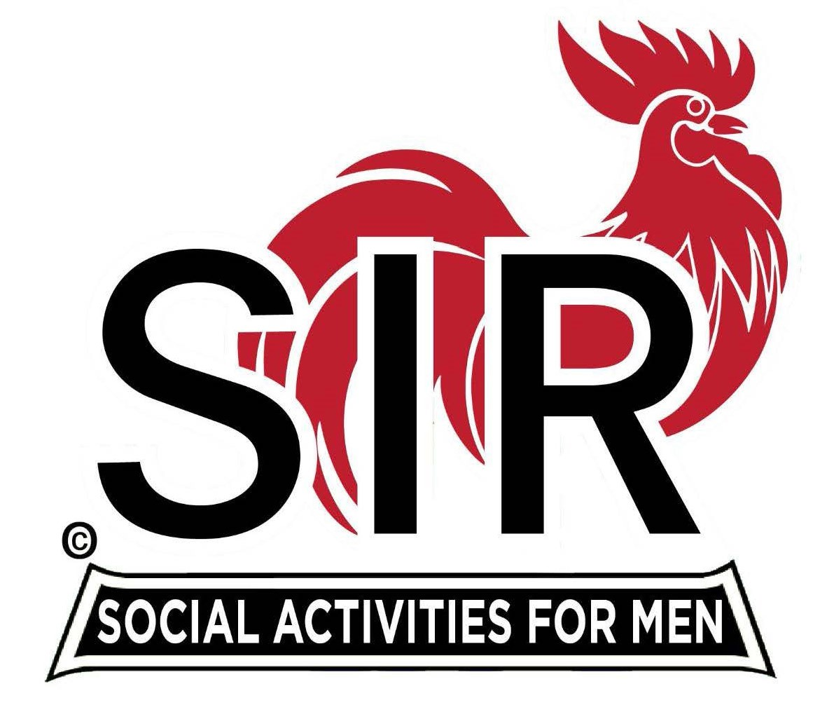
Las Trampas Branch 116
BEC Meeting Agenda
February 19, 2024, 9:15 AM at Boundary Oak
The Mission of SIR is to enhance the lives of our members through fun activities, events and luncheons while making friends for life.

9:15 am Call to order; Secretary, Paul Ramacciotti – Confirm quorum and
- Approval of January 15, 2024 BEC meeting minutes

9:20 am Standing Reports

- Treasurer – Jeff Johnson
  - Motion to Accept Audit Report-Jeff Johnson

- Luncheon Report – Big Sur
- February 19 Boundary Oak Estimated Count

- Membership – Alan Fitzgerald
  - New Members – Tony Latini, Sponsor -Gary Halick; Ken Riddings, Sponsor-Bob Colvin
  - Guests- Jim Wohlleb, Sponsor-Don Beioff; Garrett Romain, Sponsor-Steve Beck
Bill Curry, Sponsor-Phil Goff; Rob Stevens, Sponsor-Robin Lemmo

- RAMP Department Head Reports:
- Recruitment – Don Schroeder
- Activity Coordinator – Mike Ward
  - Branch 116 Activity Survey – requires a motion to approve
  - Community Service -Jeff Johnson-motion for approval
- Member Relations - Sam Beret
- Publicity – Robin Lemmo
  - Diablo Gazette

9:40 am Little SIR Updates – Paul Russell
- Speaker Info – Jim Griesemer on AI
- Birthday Boys – February

9:50 am Updates & New Business
- Nominating Committee – Roger Craig
- Resolution and recognition of Matt Arena – Dave Williams
- Spring Fling and Holiday Party – Alan Pope

10:15 am Adjourn: Lunch Preparations

